IIS7 Web Deployment

Import Application Deployment

This method involves using the IIS 7 managers ability to add an web application via “Import Application” A packaged deployment file, create using “build package” is used. A form with set of parameters is displayed.

Requires:

* IIS 7
  + ASP.Net 4.0 classic App Pool
* .Net 4.0 (can be installed via the Web Platform Installer)
* Install via Web Platform Installer
  + ASP MVC 3.

Steps:

* Download package and unzip
* Start IIS 7 Manager
* Create a new Application (directory) using “ASP.Net 4.0 classic” app pool
* Import Application
* Set Parameters
  + Application Path (this example GenericWs2)
  + NetworkCode
  + VocabularyCode
  + Contact Email
  + ConnectionString: ODDM
* Disable dynamic compression is WFS is not working
* Test

Parameters that you will need to know in order to install.

|  |  |  |
| --- | --- | --- |
| Parameter | Your value |  |
| Application Path |  |  |
| NetworkCode |  |  |
| VocabularyCode |  |  |
| Contact Email |  |  |
| ConnectionString For ODM |  |  |

Detailed Steps:

# Prerequisites

## Web Platform Installer

Install it from: <http://www.microsoft.com/web/downloads/platform.aspx>

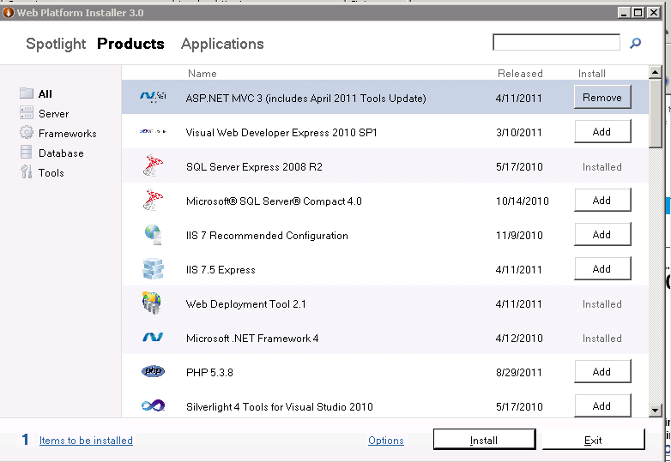The web platform installer will download and install components, frameworks, and web applications. It can even do items like PHP

If not installed install:

* .net 4.0
* ASP MVC 3.0

# Install:

0) Download package and unzip

GenericWs2.deploy.zip

<http://water.sdsc.edu/softwarereleases/GenericODWebServices/beta/GenericWs2.deploy.zip>

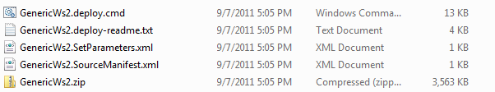

1) Open IIS 7 Manager

2) Navigate to your destination site and directory

Right Click on Default Web Site, and click Create a New Application

Create an application with a “ASP.Net 4.0 classic” app pool. This examples usesthe name “WaterOneFlow2” and a virtual directory inside the wwwroot.

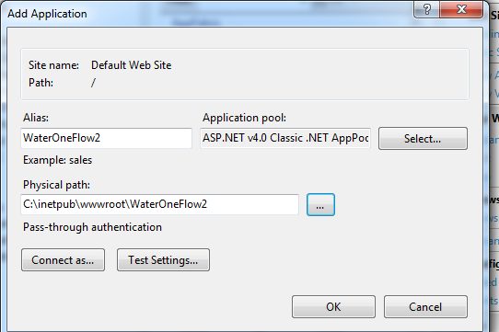

3) On the Right, in the Deploy Section, click Import Application

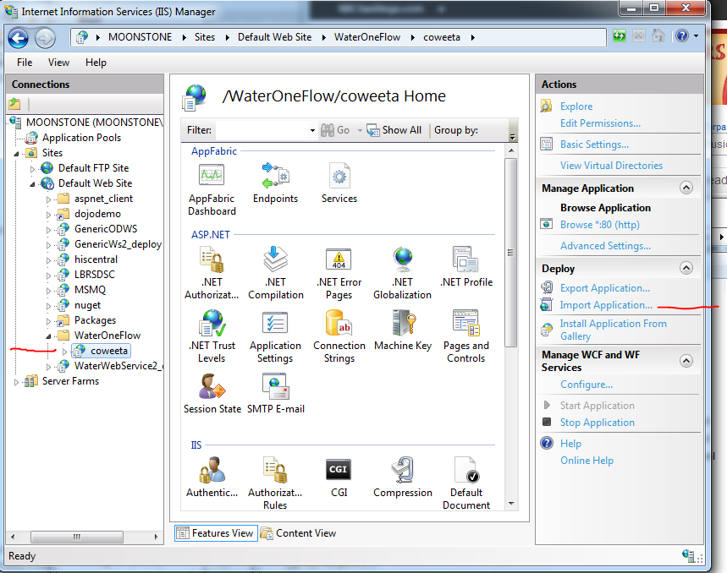

Select the GenericWs2.zip

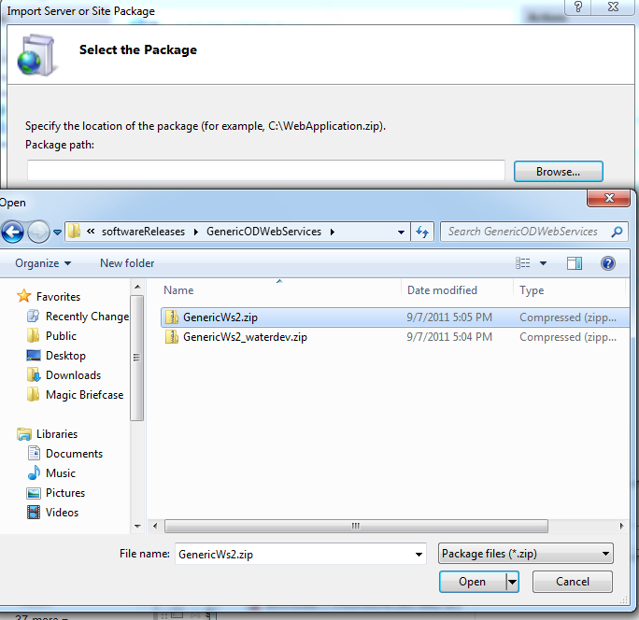

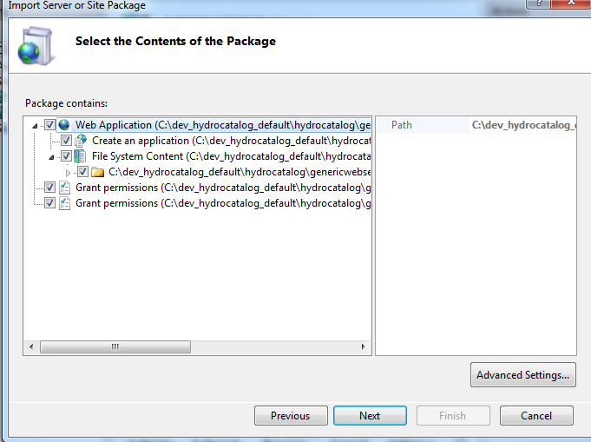

Click next.

On the Screen Enter Application Package Information:

Change the Parameters:

* Application Path (this example GenericWs2)
* NetworkCode
* VocabularyCode
* Contact Email
* ConnectionString: ODDM

Note IGNORE: elmah-sqlserver and ApplicationServices connectionStrings

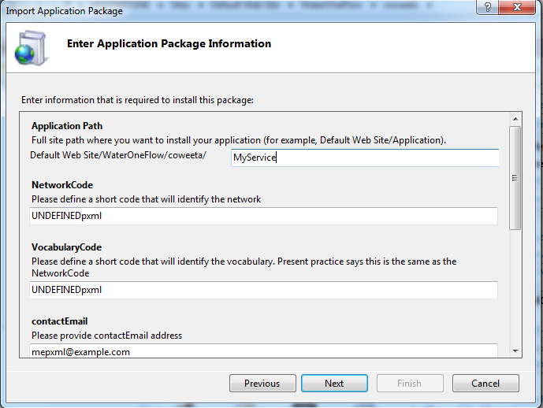

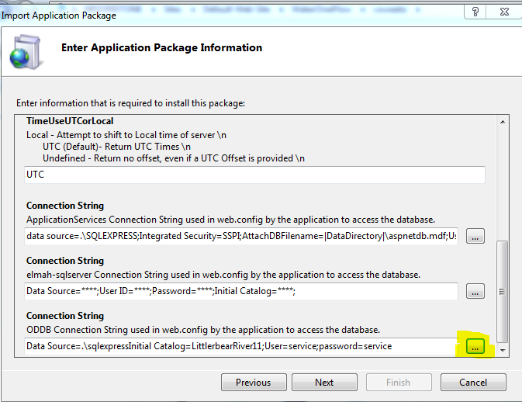

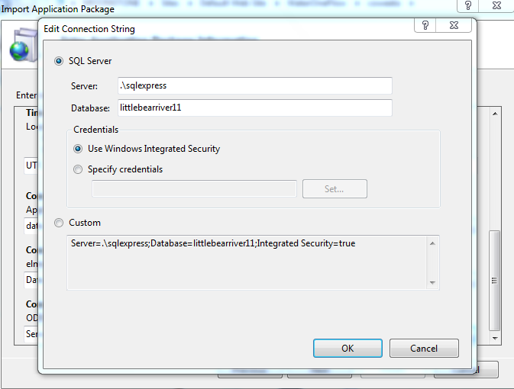

Click until finished

Refresh:

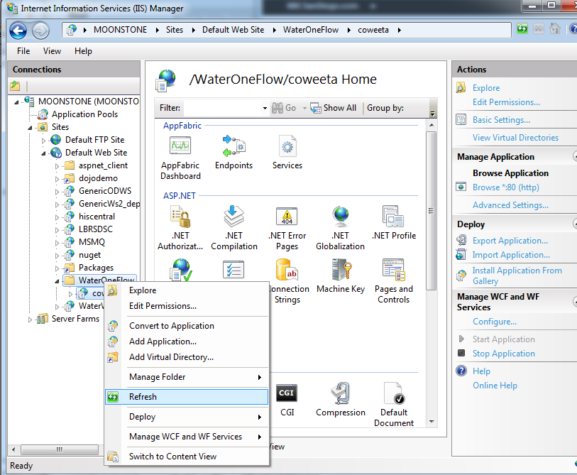

Go to the application:

<http://localhost/WaterOneFlow2/GenericWs>2

It will take a while to start. It is attempting to get the concepts from the HIS central catalog for any associated variables.

Once it does, it will look like this:

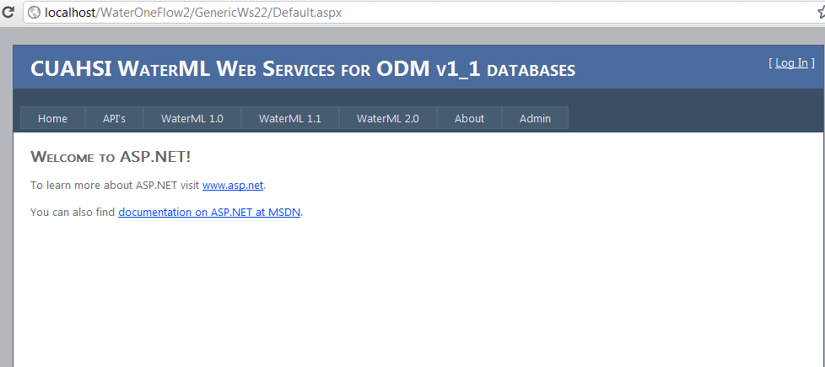

Click WaterML 1.1, and test the rest service interface

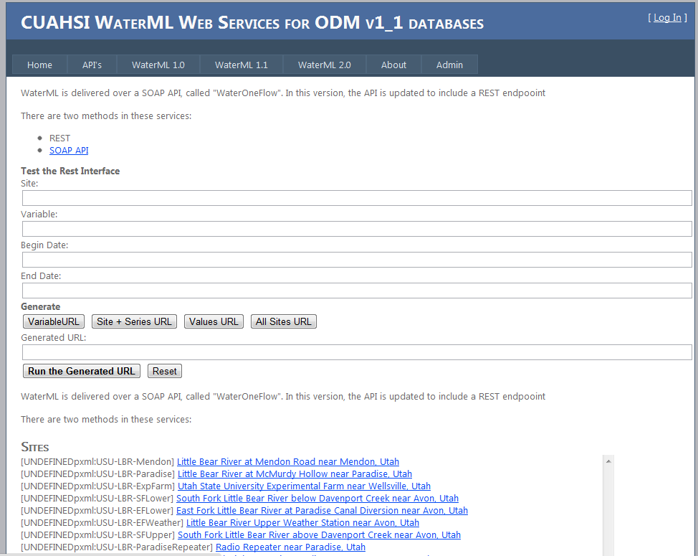

With Dynamic Compression on, you might get this:

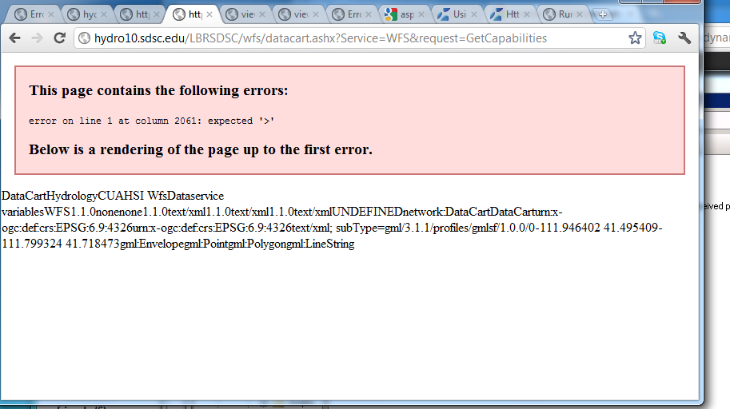

Disable dynamic compression if WFS is not working.

